

|  |
| --- |
| Course Number Section  Principles of Electrical Engineering ELEC 275 |
| Examination Date Time # of pages  Final Examination April 17, 2012 3 Hours 3 |
| Instructor(s)  Dr. S.K.Das |
| Materials allowed: x No Yes  Calculators allowed: No x Yes  Non-programmable University-approved calculators are allowed. |
| Special Instructions:  Attempt all questions.  Show all steps clearly in neat and legible handwriting.  Students are required to return question paper with exam booklet(s) |

1. Using **nodal analysis**, find **V1** , **V2**, and **V3** of Fig. 1.

( 8 marks)



Fig. 1.

2. Using **mesh analysis**, find **I1** , **I2** , and **V** of the circuit of Fig.2. Use the mesh currents shown. (8 marks)



Fig. 2.

(Page 1)

3. (a) Replace the circuit to the left of ***a****-****b*** of Fig. 3 by its

(i) **Thevenin** equivalent

(ii) **Norton** equivalent

Draw these equivalent circuits ;

(b) Determine the value of RL that will absorb maximum power ;

(c) Find this maximum power. (8 marks)



Fig. 3.

4. For the circuit of Fig.4:

(a) Draw the phasor circuit. Identify the phasors of *i(t)*, *i1(t)*, and  *v(t)* as **I**, **I1**, and **V** respectively ;

(b) Find the impedance **Z** seen by the current source (between the points ***a*** and ***b***) ;

(c) Find the phasor voltage **V**, and the phasor current **I1** ;

(d) Draw the phasor diagrams of **I**, **V**, **I1**, and **Z ;**

(e) Write the expressions for *v(t) and i1(t)*. (10 marks)



Fig. 4.

( Page 2)

5. A 60-Hz Y-connected three-phase source is supplying a balanced Y-connected load as shown in Fig.5. For this system, determine:

(a) the line-to-line voltage **vab**;

(b) the line current Ia ;

(c) the complex load power ;

(d) the apparent load power ;

(e) the real load power ;

(f) the reactive load power ;

(g) the power factor ;

(h) the capacitance **C**  to be installed to achieve unity power factor, given

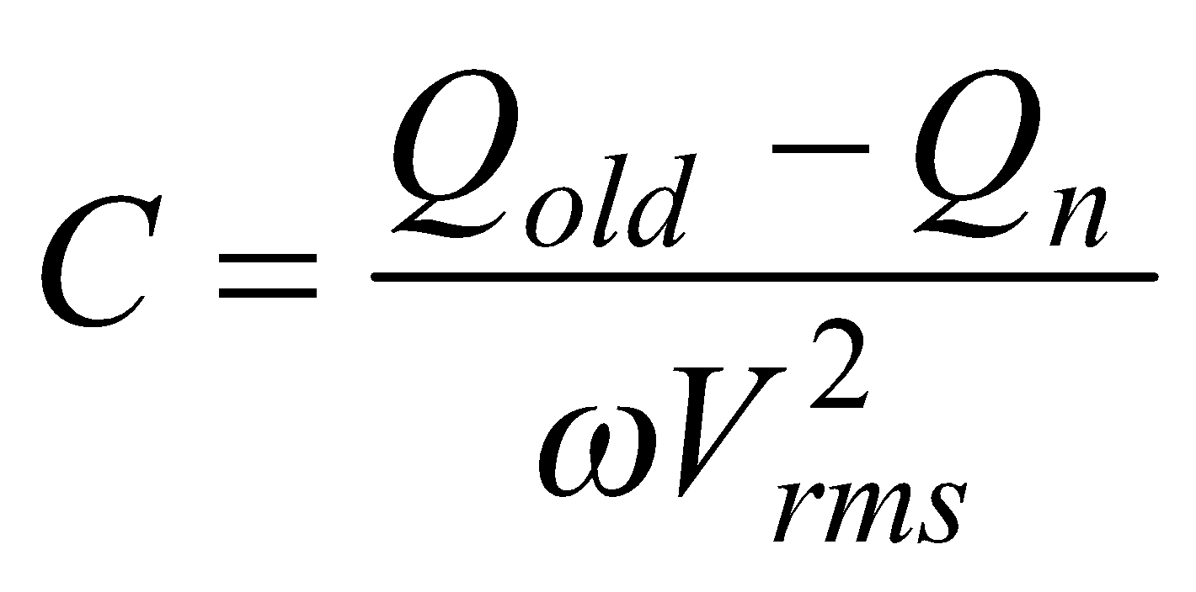. (8 marks)



Fig. 5.

6. A DC shunt motor has the following ratings:

Line (supply) voltage : 120 volts

Line current: 150 amps

Rated speed: 1200 rpm

Armature resistance: 0.2 ohms

Field resistance: 80 ohms

No-load line current: 9.5 amps

Brush drop: 2 volts.

Find:

(a) No-load speed in rpm;

(b) Speed regulation ;

(c) Rated torque in N-m

(d) Torque-speed curve (with torque in N-m and speed in rpm) ;

(e) Power output in hp (horse power) at the rated torque. (8 marks)

______________

(Page 3)